LAB 2: Information Leakage – Authorization - Web Application Security

Information Leakage
  - Remove Server Version Banner
I would say this is one of the first things to consider, as you don’t want to expose what web server version you are using. Exposing version means you are helping hacker to speedy the reconnaissance process.

The default configuration will expose Apache Version and OS type as shown below.
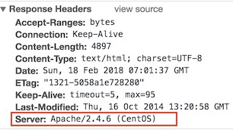

Implementation

- Go to $Web_Server folder
- Modify apache2.conf by using vi or nano editor
- Add the following directive and save the apache2.conf
ServerTokens Prod

ServerSignature Off

- Restart apache

will remove the version information from the page generated by apache web server.
ServerSignature

will change Header to production only, i.e. Apache
ServerTokens

Verification

As you can see below, version & OS information is gone.
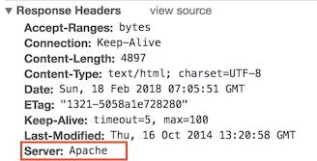

  - Disable directory browser listing

Disable directory listing in a browser, so the visitor doesn’t see what all file and folders you have under root or subdirectory.

Let’s test how does it look like in default settings.

- Go to $Web_Html directory
- Create a folder test and few files inside that
# mkdir test # touch hi
# touch hello

Now, let’s try to access Apache by http://localhost/test

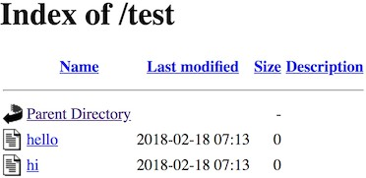

As you could see it reveals what all file/folders you have which are probably you don’t want to expose.

Implementation

- Go to $Web_Server directory
- Open apache2.conf using vi
- Search for Directory and change Options directive to None or –Indexes
<Directory /var/www/html> Options -Indexes
</Directory>

(or)
<Directory /var/www/html> Options None
</Directory>

- Restart Apache

Note: if you have multiple Directory directives in your environment, you should consider doing the same for all.

Verification

Now, let’s try to access Apache by http://localhost/test
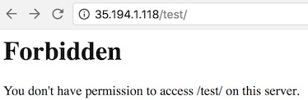

As you could see, it displays a forbidden error instead of showing test folder listing.

  - Etag

Implementation

- Go to $Web_Server directory
- Add the following directive and save the apache2.conf
FileETag None

- Restart apache

Authorization

  - Run Apache from non-privileged account

Implementation

- Create a user and group called apache
# groupadd apache

# useradd –G apache apache

- Change apache installation directory ownership to newly created non-privileged user

# chown –R apache:apache /etc/apache2

- Go to $Web_Server
- Modify apache2.conf using nano
- Search for User & Group Directive and change as non-privileged account apache
User apache

Group apache

- Save the apache2.conf
- Restart Apache

Verification

grep for running http process and ensure it’s running with apache user
# ps –ef | grep http

You should see one process is running with root. That’s because Apache is listening on port 80 and it has to be started with root.

  - Protect binary and configuration directory permission

Implementation

- Go to $Web_Server directory
- Change permission of bin and conf folder
# chmod –R 750 bin conf

  - System Settings Protection

Implementation

- Go to $Web_Server directory
- Open apache2.conf using vi
- Search for Directory at root level
<Directory /> Options -Indexes AllowOverride None
</Directory>

- Save the apache2.conf
- Restart Apache

  - HTTP Request Methods

Implementation

- Go to $Web_Server directory
- Open apache2.conf using nano
- Search for Directory and add following

<LimitExcept GET POST HEAD> deny from all
</LimitExcept>

- Restart Apache

Web Application Security
Apache web server misconfiguration or not hardened properly can exploit web application. It’s critical to harden your web server configuration.

  - Cookies
    - Disable Trace HTTP Request

By default Trace method is enabled in Apache web server.

Having this enabled can allow Cross Site Tracing attack and potentially giving an option to a hacker to steal cookie information. Let’s see how it looks like in default configuration.

      - Do a telnet web server IP with listening port
      - Make a TRACE request as shown below
#telnet localhost 80

Trying 127.0.0.1...

Connected to localhost. Escape character is '^]'. TRACE / HTTP/1.1 Host: test
HTTP/1.1 200 OK

Date: Sat, 31 Aug 2013 02:13:24 GMT

Server: Apache

Transfer-Encoding: chunked Content-Type: message/http 20 TRACE / HTTP/1.1
Host: test 0
Connection closed by foreign host.#

As you could see in above TRACE request, it has responded my query. Let’s disable it and test it.

Implementation

      - Go to $Web_Server directory
      - Add the following directive and save the apache2.conf

TraceEnable off

      - Restart apache

Verification

      - Do a telnet web server IP with listen port and make a TRACE request as shown below
#telnet localhost 80

Trying 127.0.0.1...

Connected to localhost.

Escape character is '^]'. TRACE / HTTP/1.1 Host: test
HTTP/1.1 405 Method Not Allowed

Date: Sat, 31 Aug 2013 02:18:27 GMT

Server: Apache Allow:Content-Length: 223Content-Type: text/html; charset=iso-8859-1
<!DOCTYPE HTML PUBLIC "-//IETF//DTD HTML 2.0//EN"> <html><head>

<title>405 Method Not Allowed</title> </head><body>

<h1>Method Not Allowed</h1>
<p>The requested method TRACE is not allowed for the URL /.</p> </body></html> Connection closed by foreign host.#

As you could see in above TRACE request, it has blocked my request with HTTP 405 Method Not Allowed.

Now, this web server doesn’t allow TRACE request and help in blocking Cross Site Tracing attack.

    - Set cookie with HttpOnly and Secure flag

Implementation

      - Ensure mod_headers.so is enabled in your apache2.conf
      - Go to $Web_Server directory
      - Add the following directive and save the apache2.conf
Header edit Set-Cookie ^(.*)$ $1;HttpOnly;Secure

      - Restart apache

  - Clickjacking Attack

Implementation:

- Ensure mod_headers.so is enabled in your apache2.conf
- Go to $Web_Server directory
- Add the following directive and save the apache2.conf
Header always append X-Frame-Options SAMEORIGIN

- Restart apache

Verification
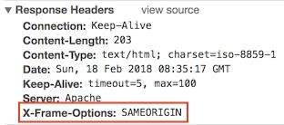

X-Frame-Options also support two more options which I explained here.

  - Server Side Include

Implementation

- Go to $Web_Server directory
- Open apache2.conf using nano
- Search for Directory and add Includes in Options directive
<Directory /etc/apache2/htdocs> Options –Indexes -Includes Order allow,denyAllow from all
</Directory>

- Restart Apache

Note: if you have multiple Directory directives in your environment, you should consider doing the same for all.

  - X-XSS Protection

Implementation

- Go to $Web_Server directory
- Open apache2.conf using vi and add following Header directive
Header set X-XSS-Protection "1; mode=block"

- Restart Apache

Verification

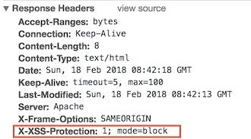

  - Disable HTTP 1.0 Protocol

Implementation

- Ensure to load mod_rewrite module in apache2.conf file
- Enable RewriteEngine directive as following and add Rewrite condition to allow only HTTP 1.1
RewriteEngine On
RewriteCond %{THE_REQUEST} !HTTP/1.1$ RewriteRule .* - [F]

  - Timeout value configuration

Implementation

- Go to $Web_Server directory
- Open apache2.conf using nano
- Add following in apache2.conf
Timeout 60

1- Yêu cầu và chấm điểm:
2- http://localhost/test >> Forbidden, Header: Server: Apache (No OS)
(CTR+Shift+E : Insp Element>develop > Network) (0.2)
2.2. Disable directory browser listing: KHÔNG cho phép liệt kê nội dung thư mục (0.2)
Thư mục /test/ chứa 2 tập tin hi và hello
=> /test sẽ báo lỗi forbidden; /test/hi sẽ hiển thị họ tên sinh viên

3- ps –ef | grep apache
You should see one process is running with root. That’s because Apache is listening on
port 80 and it has to be started with root.
(0.1)

4- telnet localhost 80
Trying 127.0.0.1...
Connected to localhost.
Escape character is '^]'.
TRACE / HTTP/1.1 Host: test
HTTP/1.1 200 OK => HTTP/1.1 405 Method Not Allowed
(0.1)

4.2: Clickjacking: X-Frame-Options: SAMEORIGIN (0.2)
4.4: X-XSS Protection: X-XSS Protection:1; mode=block (0.2)

